**Theory Questions PROI 2EV**

## UD3

**How many layers does the TCP/IP architecture have?**

4 The TCP/IP Protocol Stack is made up of four primary layers.

**What is the name of the different layers of the TCP/IP architecture?**

Link, Internet, Transport, Application.

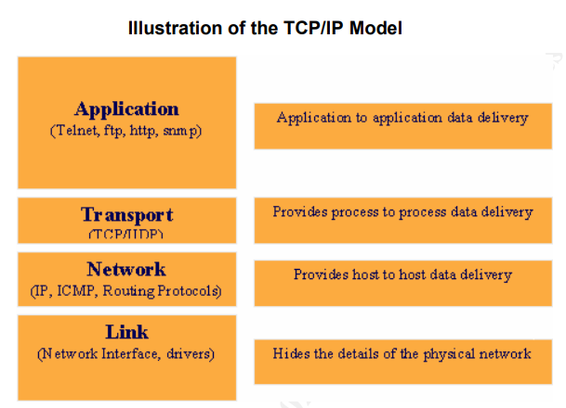

**In which layer of the TCP/IP architecture are the TCP and UDP protocols?**

Transport

**What package does the Java API have to program network applications?**

java.net provides the classes for implementing networking applications.

**How many bits do IP addresses and ports take up in network communications?**

The machine is identified by a 32-bit IP address.

Ports are identified by a 16-bit number.

**Which range of ports is reserved in computers for the use of specific applications?**

0-1023

**What is the client-server model based on?**

The Client: program that the user executes and that requests service from the Server.

The Server: offers service to multiple Clients.

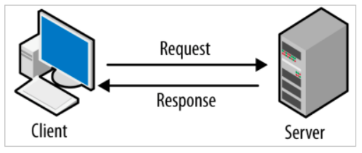

**Put 2 examples of applications that work under the client-server model.**

Moodle, ftp, web, ssh

**Which are the differences between TCP and UDP protocols within the transport layer of the TCP/IP architecture?**

TCP: Transmission Control Protocol

Connection-oriented protocol.

Provides a reliable byte stream between two computers.

Arrival in order, correct, without losing anything. If not, an error will be reported.

Application level protocols that use TCP: http, ftp.

UDP: User Datagram Protocol

Not connection-oriented protocol.

Sends independent data packets (datagrams), with no guarantees that they will reach the destination.

Allows broadcast.

Application level protocols that use UDP: tftp, ping.

**Do you think Java will have different classes to handle TCP objects and UDP objects?**

InetAddress class: to manipulate IP addresses and domain names.

URL, URLConnection, and ServerSocket, Socket classes: they use the TCP protocol for network communications.

DatagramPacket, DatagramSocket, MulticastSocket classes: they use the UDP protocol for network communications.

**What do URLs represent on the Internet?**

They represent universal resource locators.

**What do you understand by sockets in network communications?**

They are the basic two-way data communication mechanisms.

**What is the difference between a packet and a datagram?**

The term datagram is often considered synonymous to packet but there are some nuances. The term datagram is generally reserved for packets of an unreliable service, which cannot notify the sender if delivery fails, while the term packet applies to any packet, reliable or not. Datagrams are the IP packets that provide a quick and unreliable service like UDP, and all IP packets are datagrams; however, at the TCP layer, what is termed a TCP segment is the sometimes necessary IP fragmentation of a datagram, but those are referred to as "packets".

**What do you understand by multicast group?**

A multicast group is a group of computers (more specifically, network interfaces) interested in receiving a particular stream of data.

**Do you think it will be possible to send objects through sockets?**

Yes, it is.

**What is the Serializable Java interface for?**

It allows to send objects through streams.

**With what concept of Java do you think a server can serve several clients simultaneously?**

Multithreading

**What range of values can the port numbers take on the machines?**

0-65536

## UD4

**Review of protocol name**

**DNS** Domain Name System

**NFS** Network File System

**SNMP** Simple Network Management Protocol

**HTTP** Hypertext Transfer Protocol

**POP** Post Office Protocol

**UPD** User Datagram Protocol

**ICMP** Internet Control Message Protocol

**TCP** Transmission Control Protocol

**IP** Internet Protocol

**TFTP** Trivial Transfer File Protocol

**NAT** Network Address Translation

**SMTP** Simple Mail Transfer Protocol

**FTP** File Transfer Protocol

**IMAP** Internet Message Access Protocol

**DHCP** Dynamic Host Configuration Protocol

**WHAT DO YOU MEAN BY SERVICE?**

Services are auxiliary programs used in a computer system to manage a collection of resources and provide their functionality to users and applications.

**WHAT ARE THE LAYERS OF THE TCP/IP MODEL NAMED?**

Application, Internet, Transport, Network

**WHAT INTERNET SERVICES DO YOU KNOW THAT BELONG TO THE APPLICATION LAYER OF THE TCP/IP MODEL?**

FTP, POP3, IMAP, SMTP, HTTP, …

**WHAT INTERNET SERVICES DO YOU KNOW THAT BELONG TO THE INTERNET LAYER OF THE TCP/IP MODEL?**

IP

**HOW IS A JAVA LIBRARY INTEGRATED INTO A JAVA PROJECT WITHIN THE ECLIPSE IDE?**

With the build path/Library/Class Path (at a Java project level)

**WHAT DO YOU THINK THE APACHE COMMONS NET LIBRARY CAN BE USED FOR?**

To be able to use some Java classes intended to manage Net services

implements the client side of many basic Internet protocols

**WHAT IS THE FTP NETWORK SERVICE USED FOR?**

FTP is one of the most useful tools for exchanging files between different computers and is the most common form of publishing on the Internet.

**DO YOU KNOW THE TWO WAYS TO ACCESS THE FTP NETWORK SERVICE?**

Anonymous access: when the connection to the server machine is made by an unauthenticated user with few privileges on the server. In this case, the user is confined to a public directory where they are only allowed to download files.

Authorised access: the user connecting to the server machine is registered and has certain privileges on the server. In this case, and once authenticated, the user is confined to their personal directory where they can upload and download files; normally they are assigned a space quota.

**HOW MANY AND WHICH TCP CONNECTIONS DO YOU THINK ARE USED IN THE FTP NETWORK SERVICE BETWEEN A CLIENT AND A SERVER?**

FTP uses 2 different TCP connections: a control connection and a data transfer connection.

When a client connects to an FTP server, the client uses a random port but the server connects to port 21. For data transfer, the same ports are not used, so the client gets a new port and the server usually uses port 20.

**WHAT IS ABOUT THE FTP CONNECTION CALLED PASSIVE MODE?**

Active mode: the server always creates the data connection on its port 20, while on the client side the data connection is associated with a random port greater than 1024. To do this, the client sends a PORT command to the server over the control connection, indicating this port number, so that the server can open a data connection on the specified port where the files will be transferred. This has a security problem, since the client machine must be willing to accept any incoming connection on a port higher than 1024, with the problems that this involves if the computer is connected to an insecure network such as the Internet. In fact, firewalls installed on the machine to prevent attacks will most likely reject such random connections. To solve this, there is the passive mode.

Passive mode: when the client sends a PASV command on the control connection, the FTP server indicates via the control connection the port (greater than 1024 of the server, e.g. port 2040) to which the client should connect. The client initiates a connection from the port following the control port (example: 1036) to the server port specified above (example: 2040).

**DO YOU KNOW WHAT THE RedIris ACADEMIC AND RESEARCH NETWORK DOES?**

It is a public organization providing network services to Public Administrations

**WHAT FILE OPERATIONS CAN BE CARRIED OUT IN FTP SERVERS?**

Upload, download, rename, delete

**WHAT IS THE TELNET SERVICE USED FOR?**

Telnet is a network protocol used to virtually access a computer and to provide a two-way, collaborative and text-based communication channel between two machines

**WHICH SERVICE IS MORE SECURE: TELNET OR SSH?**

SSH

**WHAT PROTOCOLS DO YOU KNOW THAT ARE RELATED TO THE EMAIL SERVICE?**

POP3, IMAP, SMTP

**WHAT IS THE SMTP PROTOCOL FOR?**

The Simple Mail Transfer Protocol (SMTP) is used to deliver e-mail messages over the Internet. This protocol is used by most email clients to deliver messages to the server, and is also used by servers to forward messages to their final destination.

It works with text commands that are sent to the SMTP server (by default, it uses port 25). Each command sent by the client is followed by a response from the server, consisting of a number and a descriptive message.

**WHAT IS THE DIFFERENCE BETWEEN DOWNLOADING EMAIL MESSAGES WITH POP3 OR IMAP?**

The POP3 server is the incoming mail server and generally uses port 110. Like SMTP it works with text commands.

When downloading emails from a POP3 server they are removed from the server.

**WHAT ARE FILE SERVERS SUPPOSED TO DO?**

Its mission will be to provide access to files and folders. When the server program is started, the folder to be accessed by the clients when they connect to the server is chosen. The clients will connect to the server and will be able to upload or download files from it. The communication between client and server will be done through objects.

**WHAT DO DENIAL OF SERVICE (DoS) ATTACKS CONSIST OF?**

A attack in which you generate a lot of requests to a server in order to block the server

## UD5

When handling exceptions, is it advisable to order the catches from most specific to least specific

When handling exceptions, is it advisable, whenever possible, to put several catches and a single try in the code

Naming conventions:

**Method** → verb + noun

**Class** → noun

**Interface** → adjective

In source code files (*.java), if the class belongs to a package, the statement referring to the package is recommended to be placed at the beginning of the file.

In source code files (*.java), if a public class exists, the name of the class must correspond to the name of the file.

In general, it’s more advisable to use an empty object during the Java development process to avoid NullPointerException problems.